Step 1 : Goto installation directory of Java

It will be similar to : C:\Program Files\Java\jdk1.8.0_131\bin, copy <CTRL +C> on windows.

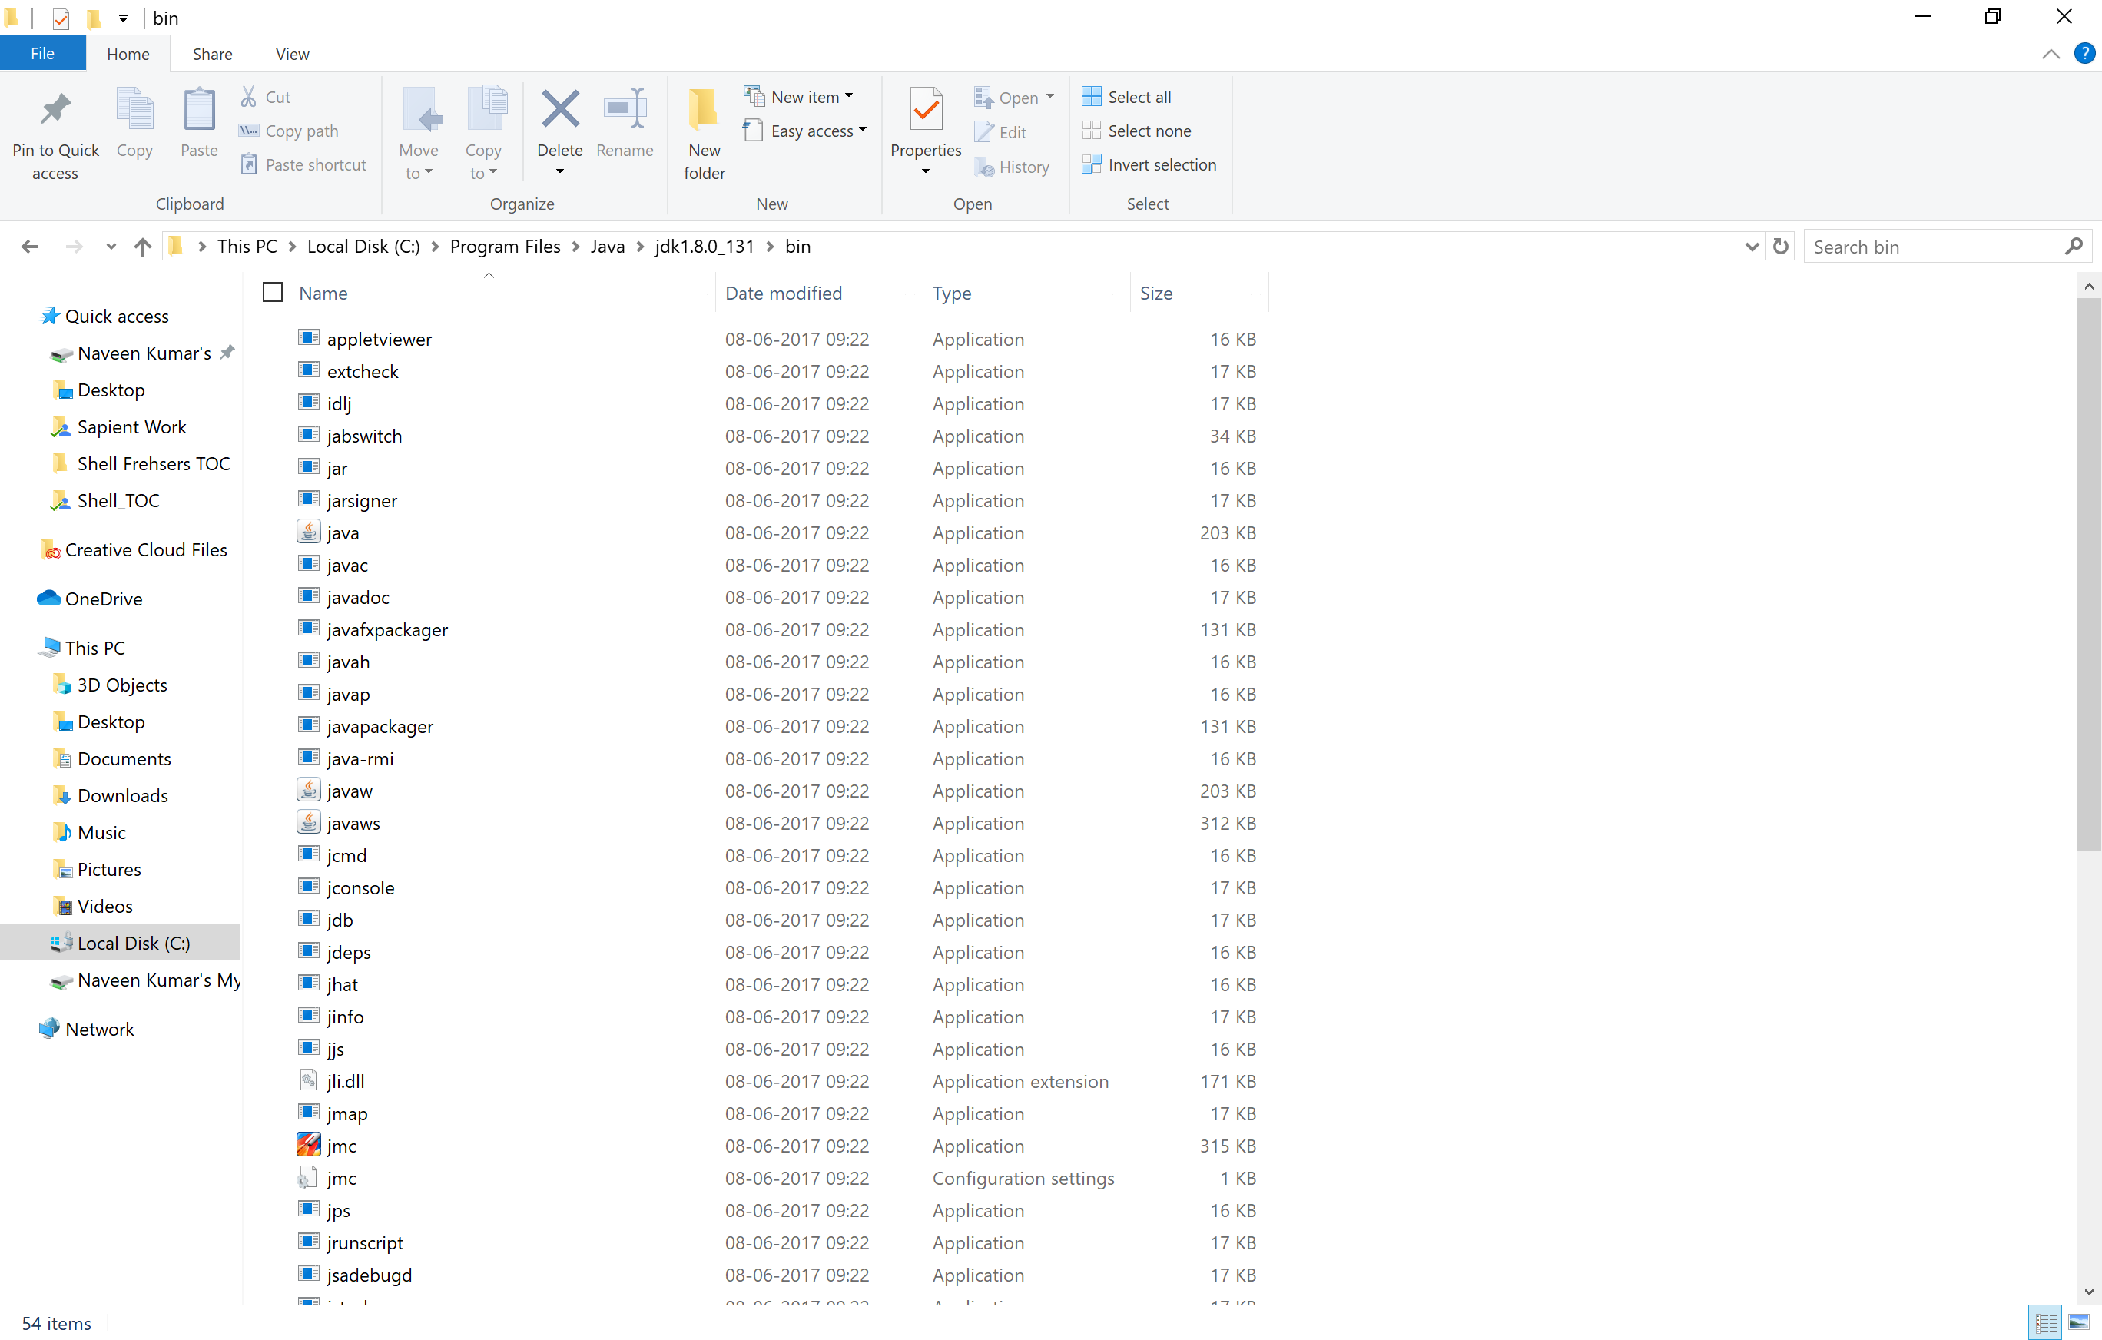

Step 2: goto my computer (right click on This PC) -> properties -> this will open a new window shown in Step 3

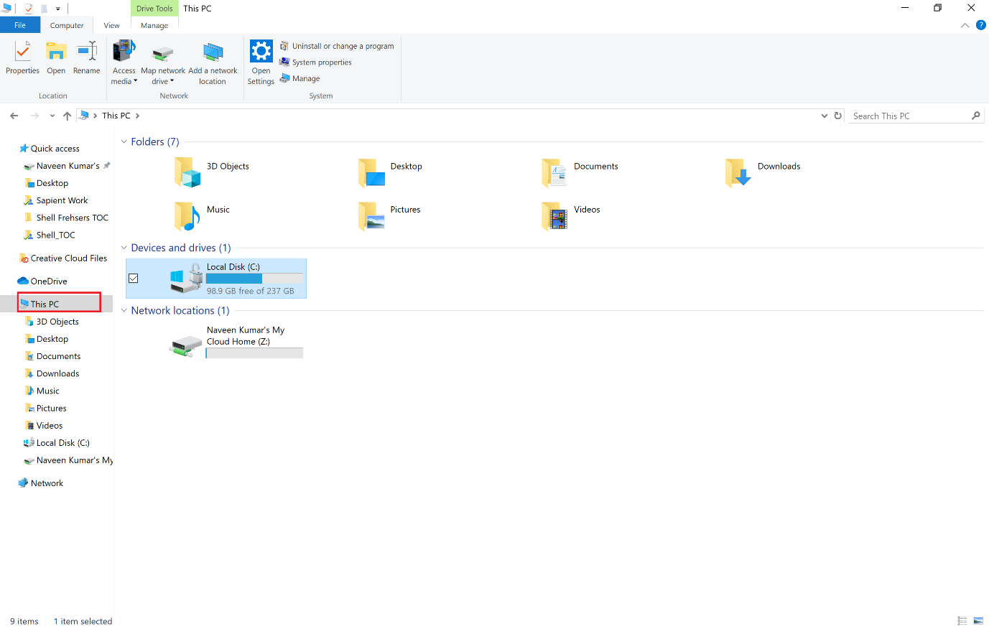

Step 3 : click on advanced System Settings which will open another screen Refer Step 4 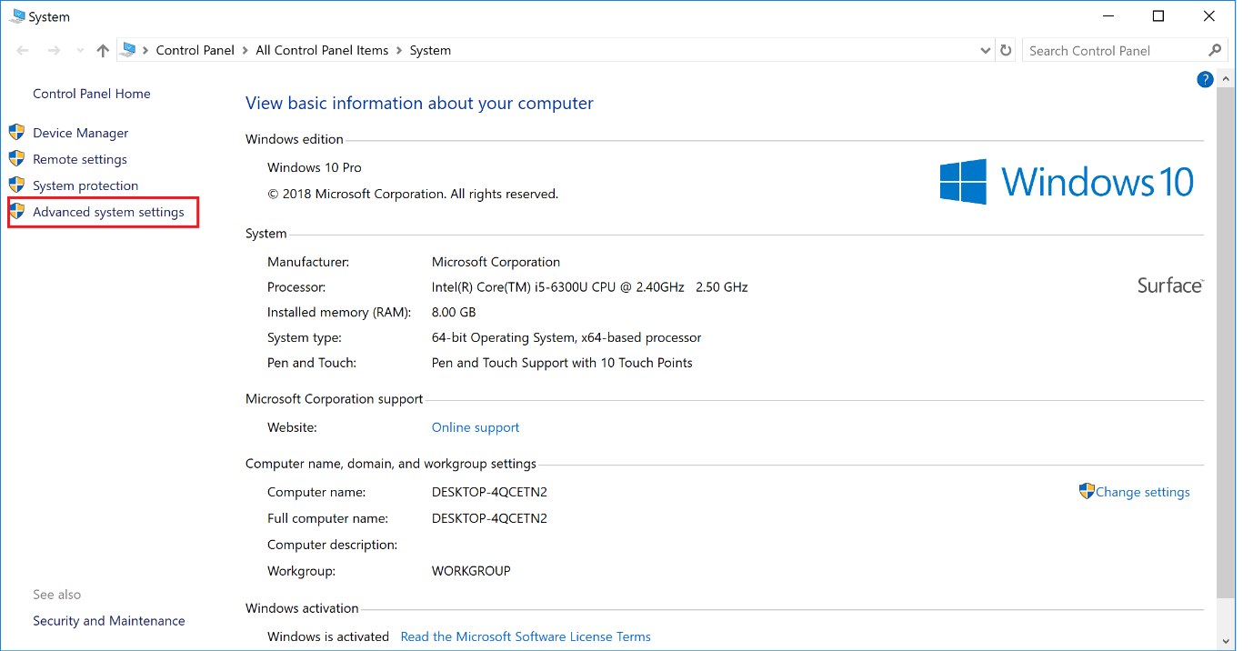

Step 4:

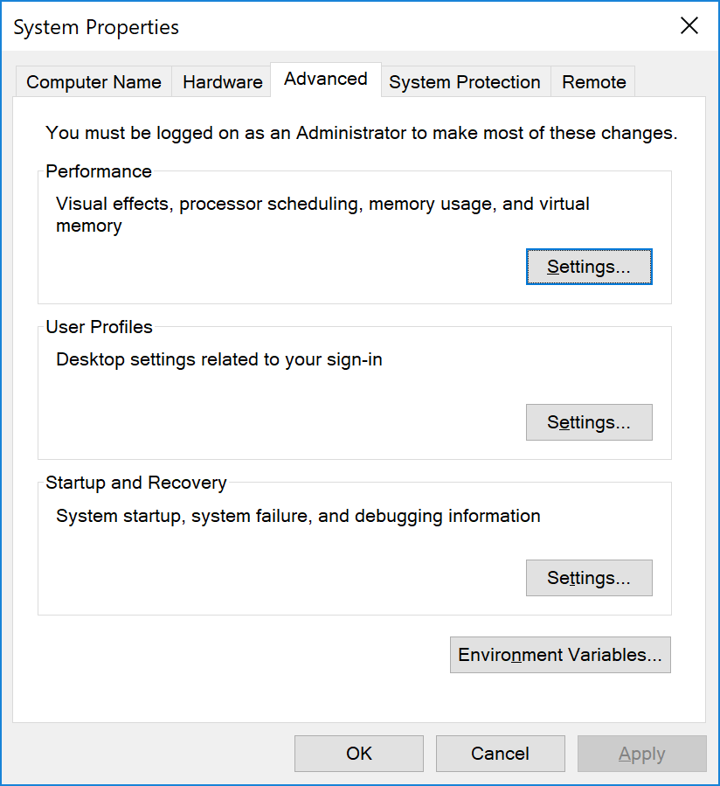

Click on “Environment Variables” as shown in the screen below you may have to check if there is a variable called “PATH “ if it is there then click on edit which will show the screen as below

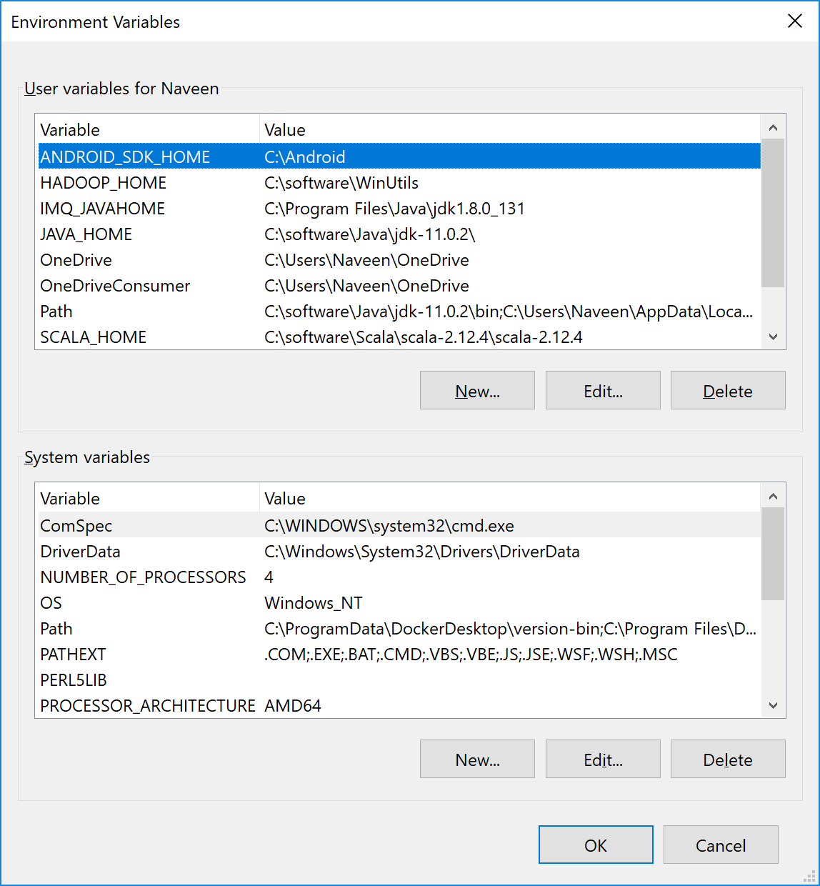

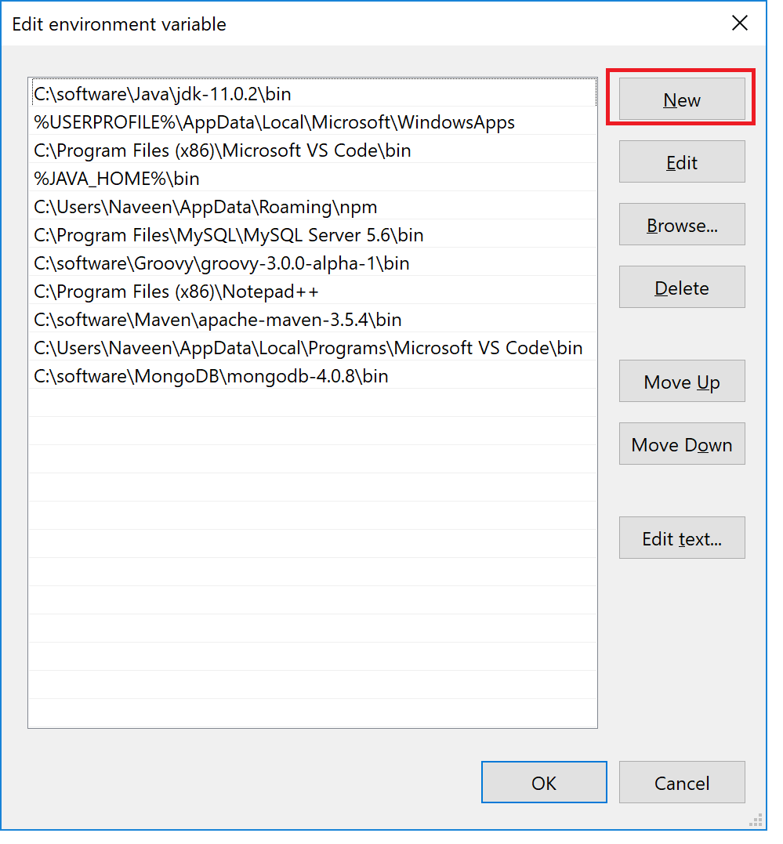

And paste the copied path from java .

If the variable “PATH” is not available then for the below instruction

Click on new

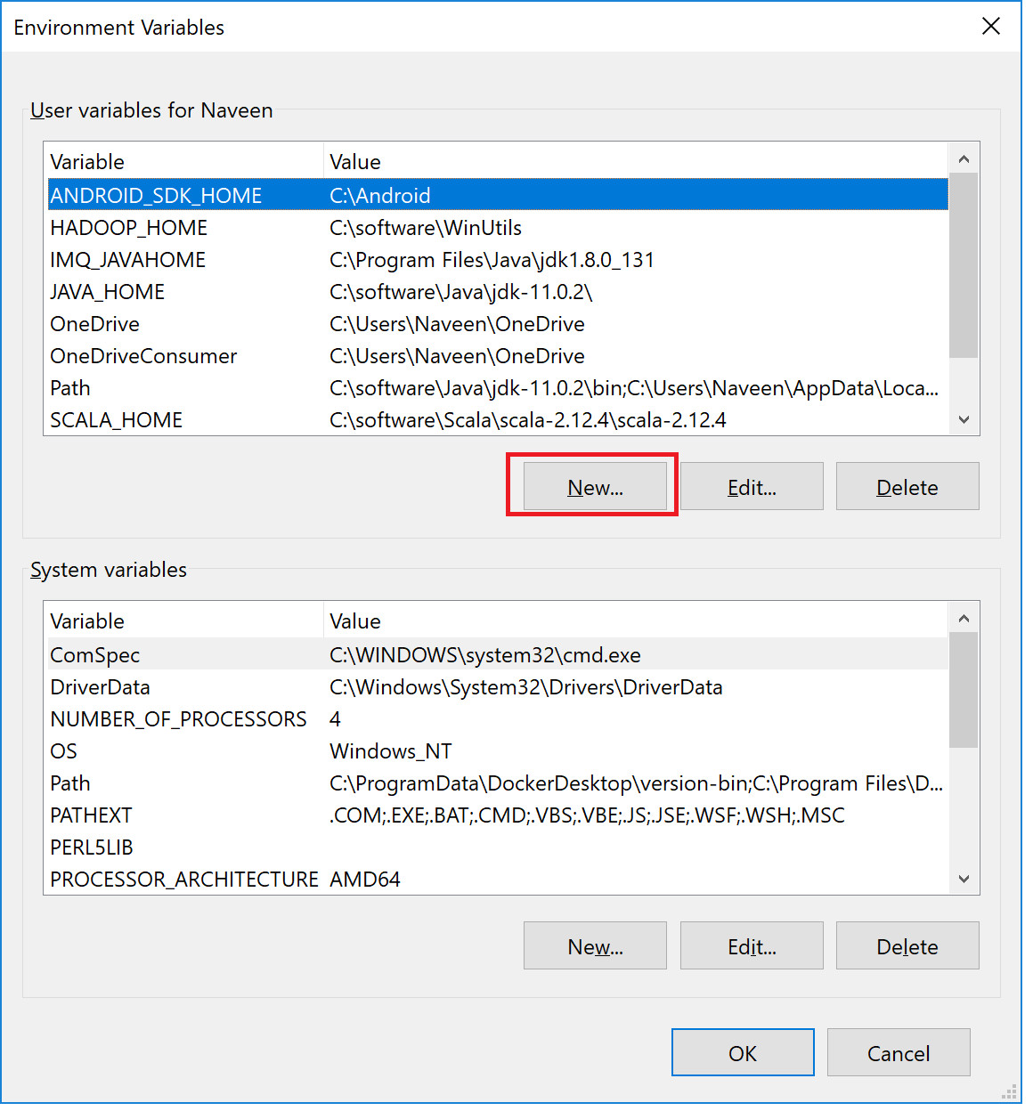

Which open a small pop up, and enter the details as shown

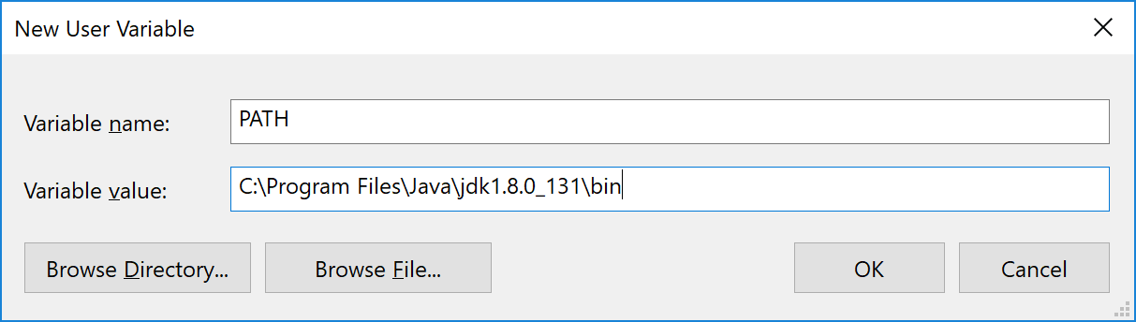

Finally save and exit.

Then open command prompt/ terminal in, and give the below command

“ > java –version”,

Which should show the version of java.